Continuing Training Needs Assessment (TNA)
(Updated Dec 2022)
Please submit by 15 June

Identifying your training needs and progress at intervals throughout your PhD will assist you both in completing your PhD effectively, and helping you develop skills of value for your future career.

All ARIES PGRs (including Associated) should complete the form. It is also a requirement for the award of the ARIES Certificate of Advanced Postgraduate Training. Please discuss your training and development needs with your supervisor(s) during the process of completing this form.

This form may duplicate information gathered separately by individual Institutes and Schools, but is nevertheless required by ARIES for assessment of the training needs of ARIES PGRs. You might wish to complete this task alongside preparing for your institutional annual progress review.

PART A. REGISTRATION DETAILS (To be completed by the student)
Surname or Family Name:
Forenames or Other Names:
Month & Year of Registration:
Expected submission date:
Current Year (please circle or delete): 1 2 3 4
Full-time / Part-time (please delete as appropriate)
Project Working Title:
University and School/Dept of Registration :
Home Institute if different from above (eg BAS, PML, etc):
PART B: Training courses and other relevant activities
Please list training undertaken during the last year only. Please see the ARIES Handbook for details and expectations.

For ARIES cohort events (Winter/Summer Schools, etc.), please simply identify these on the ‘tick’ list below.

Advanced Research (e.g. field/lab techniques, social science methodologies, etc.)
Data and Quantitative Skills Training (e.g. modelling, statistics, programming, etc.)
You should include in-person training with your research group/supervisors, etc.

Course/Training Title | Data / Quantitative Skills Training? Y/N | Approximate days/hours
Personal and Professional Development (e.g. time management, presentation skills, etc.)
Course/Training Title |  | Approximate days/hours
Careers-related Training (e.g. writing a CV, interview skills)
Course/Training Title |  | Approximate days/hours
Experiential learning (e.g. conference attendance/presentation, public engagement, organising an activity, etc.)
Activity/conference Title |  | Approximate days/hours
Please indicate ARIES cohort training events attended:
Event |  | Attendance  (underline or delete)
Induction |  | Y / N / n/a
Year 1 Winter School |  | Y / N / n/a
Year 1 Summer School |  | Y / N / n/a
Year 2 Winter Retreat |  | Y / N / n/a
Year 3 Summer School |  | Y / N / n/a
CEEDA/CADA Student Symposium (enter year[s] attended or n/a)
Have you presented a poster or given an oral presentation at the CEEDA Student Symposium? |  | Y / N / n/a
envEXPO/enviroSPRINT (enter year[s] attended or n/a)

PART C: Reflection on progress towards your training targets
Please reflect on your development to date in both research and broader transferable skills in terms of the Vitae ‘Researcher Development Framework’ (RDF) Domains below. Reference your progress to your previous Initial or Continuing TNA. Consider whether you have met earlier objectives, resolved any issues previously highlighted, and describe future objectives. You might note any frustrations or barriers to progress (there is a separate section on COVID).

The ARIES training expectations are that:
“By the end of your studentship, you will have demonstrated progression to a higher ‘phase’ for some of the ‘descriptors’ in each of the four RDF Domains. These will reflect your stated personal and professional development and career objectives.”

For each Domain reflect on your development over the last year (~200 - 400 words) and use this to develop plans for the coming year (~100 - 200 words). Try to set “Specific, Measurable, Attainable, Relevant and Timely” (SMART) goals for yourself.

The Vitae RDF Planner is presented in Annex 1, and an example of an idealised reflective report is included in Annex 2.

Domain A: Knowledge & Intellectual Abilities
Reflect on your development and plans for coming year (set SMART goals as appropriate)

Domain B: Personal Effectiveness
Reflect on your development and plans for coming year (set SMART goals as appropriate)

Domain C: Research Governance and Organisation
Reflect on your development and plans for coming year (set SMART goals as appropriate)

Domain D Engagement, Influence and Impact
Reflect on your development and plans for coming year (set SMART goals as appropriate)

Interaction with your Independent Research Impact Adviser (IRIA) - OPTIONAL
(Some PGRs currently do not have an IRIA; contact us if you would like to explore this option)
We welcome your feedback on this pilot scheme; if you prefer to do so confidentially then please send comments directly to aries.dtp@uea.ac.uk. Thank you.

Name of IRIA:

Did they contact you before you started your PhD?:

Y / N / can’t remember (please underline or delete)

How many times have you been in contact with them over the past 12 months?:
1 2 3 4 >4 (please underline or delete)

How have you been in contact (email, video call, in person):

email, voice/video, in person, other …….…….. (please underline, delete or add)

Please give us your opinion of the scheme, including any positives, negatives and suggestions for improvement.

COVID-19 impacts - OPTIONAL
You can use this section to record any impacts from the COVID-19 pandemic not mentioned above that you would like to bring to our attention. You might include impacts on your training, your ability to attend events and conferences, placements and engagement with external partners (e.g. CASE sponsors), and adjustments you may have made to your research programme. Has this period afforded any unexpected opportunities? Has it influenced your thinking on career objectives?

Please continue to maintain your COVID Risk Register (see www.aries-dtp.ac.uk/handbook-and-forms/) in case needed for future concessions.

PART D: Required written work
ARIES requires students to have completed the following written tasks. You do not need to send these to us, simply confirm that they have been completed.
Please underline or delete Y/N as appropriate.
By the end of Year 1 it is expected that you will have submitted (as a minimum):

- A literature review Y/N
- PhD project research outline, work plan and timetable for the next year Y/N
These will likely be the documents you submit as part of your first institutional Annual Progress Review/Probationary Meeting, as applicable
By the end of year 2 it is expected you will have submitted:

- A structured piece of scientific writing; e.g. a draft paper or thesis chapter Y/N

This might be work submitted as part of your second Annual Progress Review
By the end of year 3 it is expected that students will have submitted (as a minimum):

- Draft thesis chapter or draft paper (i.e. in addition to that submitted in Year 2) Y/N
- A detailed plan for the thesis and its completion Y/N

This might be work submitted as part of your third Annual Progress Review

ARIES expects you to carry out advanced Data and Quantitative Skills Training appropriate to your research or professional development (typically 2-5 days over the period of study). Details are entered in Part B above.

I have completed this training Y/N
If you have not yet had your annual progress/review meeting for this year (perhaps because you started your PhD later in the academic year), please give the planned date for the meeting here:

PART E: Signatures - required
Student:
Once completed, please email this form to ARIES at aries.dtp@uea.ac.uk. The ARIES Training and Progression Panel will review your submission and send you feedback.

Signature: ……………………………………………….. Date ……………….……………...
Supervisor’s comments on PGR’s progress (ARIES values your comments):

I confirm that I have read this report, that the required work has been submitted, and I agree with the student’s plans for the coming year.

Primary Supervisor name: ……………………………..…………………………………….

Signature (PGR can sign on their behalf with the Supervisor’s permission):

……………………………………………………… Date ………………………..
(Typed signatures are acceptable)

PART F: Career plans
You may or may not know yet what you want to do after your PhD, and your ideas might change over time. However, reflecting on your career aspirations serves to highlight areas for training and development that might support a future career. If you prefer not to share this with your supervisor, then please send this section to us separately. You may find it useful to share your thoughts with your Independent Research Impact Advisor, or to discuss them with a careers advisor at your University or Institute.

Thoughts on possible career plans

What might help towards attaining your career plans?

Annex 1: The Vitae Researcher Development Framework

The inner ring describes the four main Domains, which are divided in to Sub-domains (mid-ring), and Descriptors (outer ring)
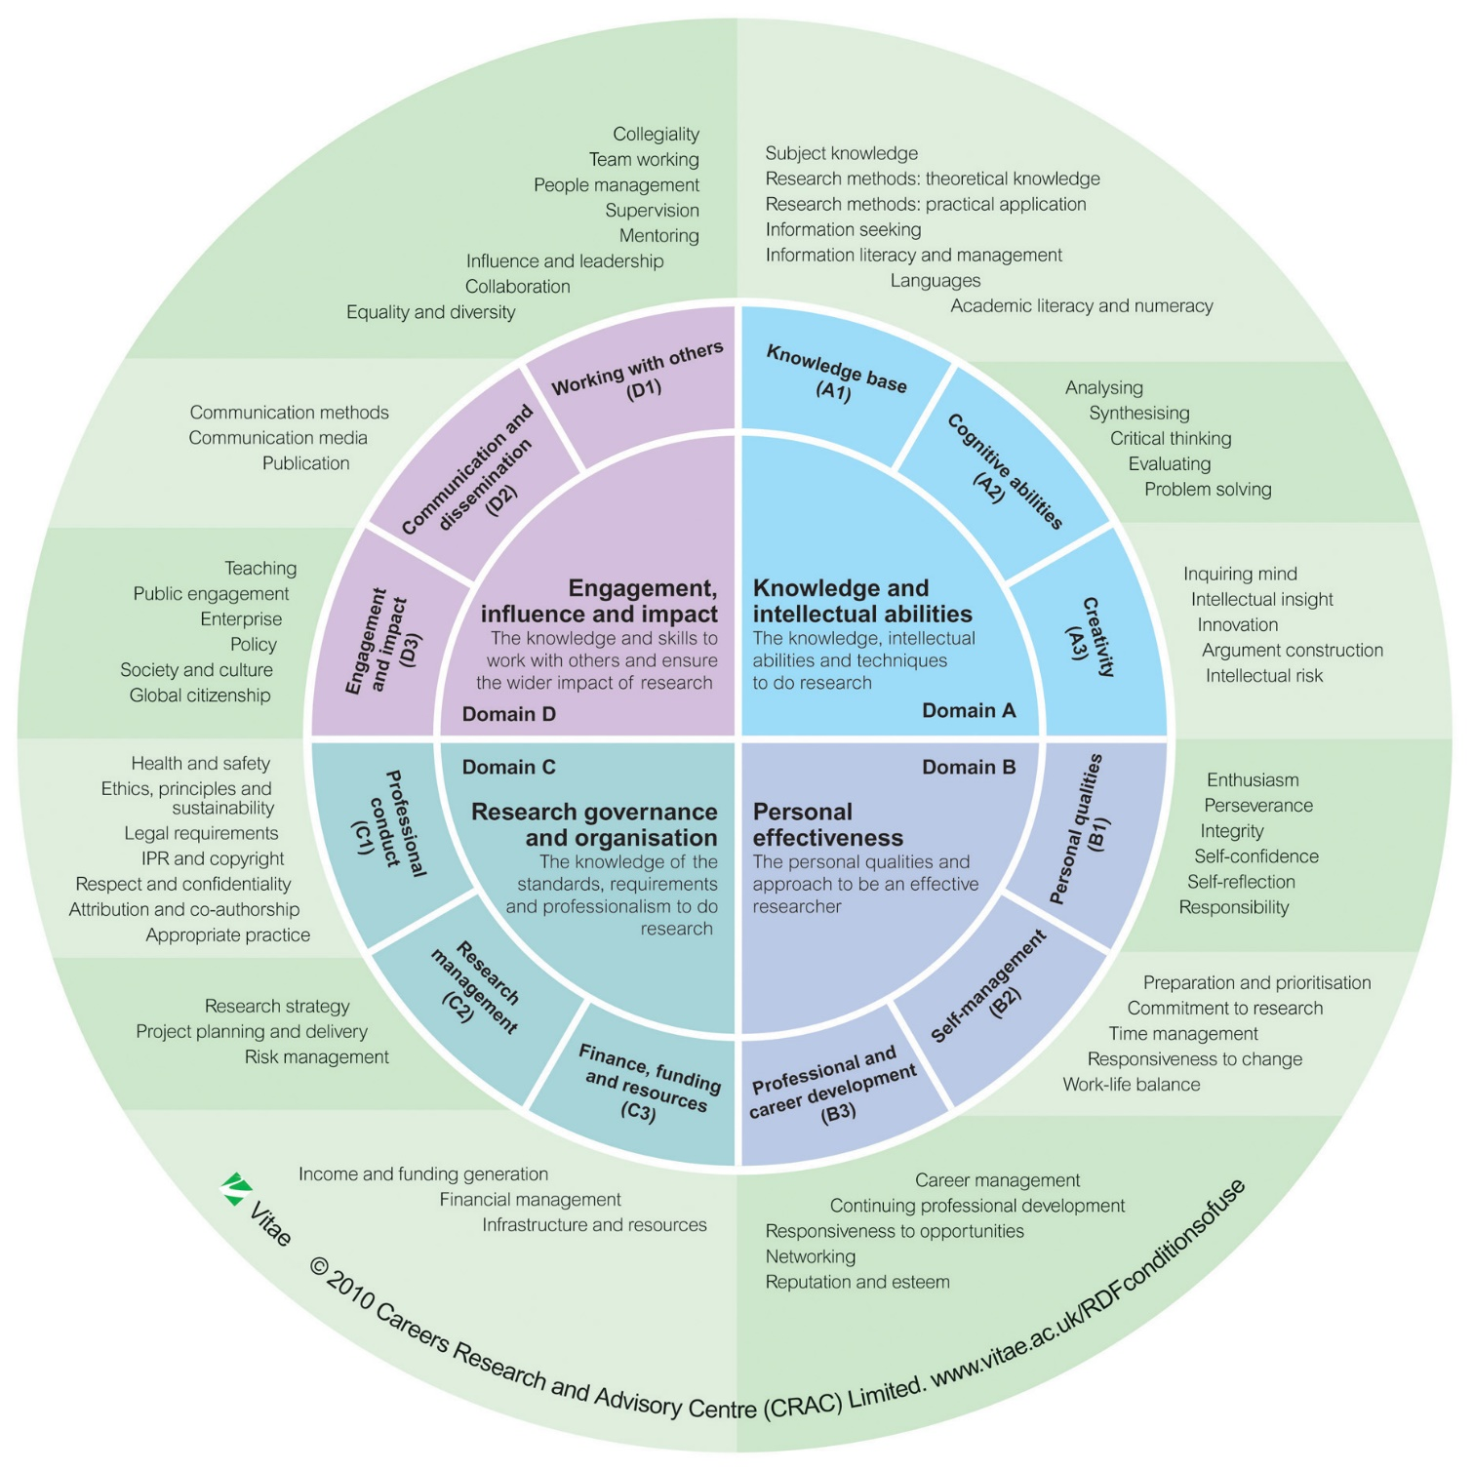

For more information please see bit.ly/Vitae_RDF
Annex 2. Example of a reflective statement (see Part C of the form)

Domain B Personal Effectiveness: reflection on development and plans for coming year

Over the last year I have worked really hard to take increasing responsibility (B1). I have been trying to be more pro-active and making more suggestions for research directions at my supervisory meetings, analysing my results in advance and working out why I have the results I do and the next steps I think I need to take in the research. This summer I also had the opportunity to help an MSc student with their work which involved taking responsibility for the work they were undertaking in the lab (steps towards Phase 3). I trained the student in the techniques needed for their research and helped them analyse their data and decide the next steps for their research.

As my PhD has evolved I have increasingly realised that I have low self-confidence and now question the “Phase 2” that I scored in my RDF planner (B1). The event that made me realise this was my probationary meeting where I was really scared about not saying the right things and not being able to answer questions properly. I discussed this with a couple of colleagues who suggested that I enrol in Springboard which is a personal development programme for women, which I did. On reflection this was an excellent course which hopefully has helped me overcome some of my confidence issues. Work in progress!

Time management has always been struggle for me (B2) and following on from the winter school I have been focussing upon improving my time-management and planning I now have an excel spreadsheet on which I have all my tasks listed in terms of importance and immediacy. This helps ensure that I prioritise the things which are important for me and my research. I now also spend 30 minutes every Monday planning my week ahead. Springboard also covered time-management issues so I feel that I am making progress (moving towards Phase 3).

Building on a profile-building session at the winter school I spent a couple of days over the summer setting up my academic profiles (B3) on the web, Linkedin, etc. with a view to more effective networking. It felt like a positive thing to do but slightly disappointing as to date I have little to put up except my Masters and the outline of my PhD. I will need to build time into my schedule to keep these updated (consolidating Phases 1 and 2). I will also explore joining appropriate user groups on Linkedin and starting a blog. SCISnack looks to be a good possibility for me in terms of blogging and building a reputation (B3).

Looking forward I would really like to work on my self-confidence and I was much more comfortable at my last supervisory meeting and even held my own with x who was critical of my experimental approach. I have signed up for a Science Museum Late at the Science museum (Dec 16th) which I would never have even contemplated 6 months ago. I may even be moving towards Phase 2! Improving time-management is another priority and there were lots of useful ideas at the ARIES Winter School. However, I now feel that I am at the stage where I simply need to trial a number of systems and find out which work for me. So the in next few weeks (by end Nov 16) I plan to try a number of different systems “e.g. Pomodoro” and see how they work for me. 2 years into my PhD and am staring to consider my career options. Would possible be interested in an academic career so have enrolled on a course (SCI4RB3Y) on ‘Applying for postdoctoral positions’.

I have registered to attend the [X] conference in Stockholm and have been accepted to give both an oral and poster presentation. I’m really enthusiastic about this opportunity (B1) and it will definitely help my self-confidence (B1). I will need to ensure that I start my preparation in plenty of time (B2). The poster session at the Winter School has given me some ideas but I’ve heard from other PGRs that the Infographics training offered through ARIES is really great so I’ll register for that when it’s advertised. I will also register to take part in SCI3RA3Y ‘Presenting your Research’ to practice my oral presentation and get feedback before arranging a practice session with my supervisors.

CONTINUING TRAINING NEEDS ASSESSMENT FEEDBACK FORM
(for completion by ARIES Training and Progression Panel)

Is the form comprehensively filled out and does it indicate sufficient engagement with training and development?

Is the student on track to complete the expected ARIES training? (Please see Handbook: e.g. all Cohort Training; Initial/Continuing TNAs; ~5 days per year Advanced Training; ~2 days per year Personal, Professional and Careers training; presenting to a major conference; Experiential Learning; Data and Quantitative Skills Training)

Has the student submitted the required written work? (See Part D)

Is the student on track to make progress to higher phases for a number of descriptors in each of the four RDF Planner Domains by the end of their Studentship?

Are there any other relevant training opportunities that might be useful to the student?

ARIES Training and Progression Panel approval
Name ................................................ Signature............................................ Date....................

