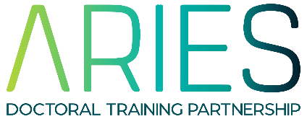
Financial Assistance
ARIES-funded PGRs
15/09/2022

ARIES recognises that not all costs can be accurately predicted in advance, and that some research costs are subject to fluctuations. This form is for ARIES-funded PGRs to apply to the DTP for further research or training funding over and above their RTSG or XMU funds. Please note that you must be up-to-date with your mandatory cohort training and TNA reporting to be eligible for DTP funds.

Supporting papers/documents may be attached. Please refer to the ARIES guidance for expenses. Applications for additional funds should be made in advance. Retrospective claims will not be considered.

Name of applicant:

Nature of application: | i.e. what will the additional funding be used for?

Details of application:

For specialist training courses only:
Was the need for this training identified in a previous TNA? YES/NO

Costs £ (itemised):
If you are claiming travel and/or subsistence costs, please refer to the ARIES guidance before completing this section.

Justification:

Supporting statement by supervisor:

Timescale of expenditure:

Have you previously received additional financial support from the ARIES DTP (i.e. not RTSG or XMU funding)? If so, please give details:

Other organisations to which applications have been made together with response or date of response:

Total amount requested (£):

Signature of applicant: (Sign and print) | Date:
Signature of supervisor: (Sign and print) | Date:

