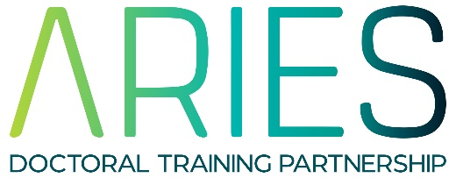
REP 2022 Project Proposal Form

29/03/2022

Lead Supervisor:

Email:

University/Research Organisation:

Department:

Project Title:

Proposed element of fieldwork, data collection, activity to give an understanding of the wider context etc
Proposed PhD mentor (if already identified)
Contingency plan
We understand that there will need to be some flexibility due to COVID19, therefore applications need to show a contingency plan for if the placement needs to change. How will the student be integrated into the department? For example, if a placement becomes computer-based, students are still invited to lab meetings and other sessions.
Project Summary (max 500 words)
Photo for advert
Please provide a suitable image for use in the web advert for this project
Preferred Student UG Degree subject(s)
Learning/Development opportunities this placement will provide
Research Costs (up to £500)
Duration (between 6 and 8 weeks)
Please note that students will be employed by the host organisation on a temporary contract and will be paid at least at the National Minimum wage and will be subject to NI and other on-costs. This may have implications on the length of studentship possible and host organisations may have internal restrictions on the minimum wage they will pay.

