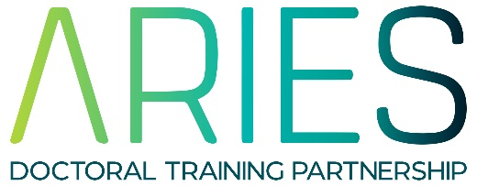
REP 2021 Project Proposal Form

15/04/2021

Lead Supervisor:

Email:

University/Research Organisation:

Department:

Project Title:

Proposed element of fieldwork, data collection, activity to give an understanding of the wider context etc
Proposed PhD mentor (if already identified)
Contingency plan
We understand that there will need to be some flexibility due to COVID19, therefore applications need to show a contingency plan for if the placement needs to change. How will the student be integrated into the department? For example, if a placement becomes computer-based, students are still invited to lab meetings and other sessions.
Project Summary (max 500 words)
Photo for advert
Please provide a suitable image for use in the web advert for this project
Preferred Student UG Degree subject(s)
Learning/Development opportunities this placement will provide
Research Costs (up to £500)
Duration (between 6 and 8 weeks)

