Continuing Skills Review
(Last updated April 2020)

Engaging with this skills review and identifying your development needs at regular intervals throughout the PhD will enable you to complete your project effectively and in good time. It will also help you develop the skills you require for your future career. For this annual review we would like you to complete and return this form to aries.dtp@uea.ac.uk.

Completing most parts of this form is mandatory and required for the award of the ARIES Certificate of Completion of Advanced Postgraduate Training. You should discuss your training and development needs with your supervisor/s before completing the form.

This form may duplicate information gathered separately by individual Institutes and Schools, but is nevertheless required by the ARIES Training and Progression Panel for assessment of the training needs and progress of individual ARIES PGRs.

PART A. REGISTRATION DETAILS (To be completed by the student)
Surname or Family Name:
Forenames or Other Names:
Month & Year of Registration:
Expected submission date:
Current Year (please circle or delete): 1 2 3 4
Full-time / Part-time (please delete as appropriate)
Project Working Title:
University and School/Dept of Registration :
Home Institute if different from above (eg BAS, PML, etc):
PART B: Training courses attended and other activities contributing to professional development
Please list the training you have undertaken during the last year in the form below. Please list these under each of the four categories of training (for further details, and a guide to our expectations see). For each please list the title of the course and an approximate number of days. This includes conferences attended (name, location and date), presentations made at a conference or elsewhere (name of event and location).

Please note you do not need to enter details of the mandatory ARIES cohort events, (Summer school etc), as these will be recorded separately.
Advanced Research (e.g. advanced instrumental techniques, social science methodologies, etc.) and Data and Quantitative Skills Training (e.g. modelling, statistics, machine learning, R, Python coding).
This can also include training within your group/with supervisors, etc.
Add lines to the tables as needed.
Course/Training Title | Data / Quantitative Skills Training? Y/N | Approximate number of days
Continuing Professional Development (e.g. time management skills)
Course/Training Title |  | Approximate number of days
Careers-related Training (e.g. writing a CV)
Course/Training Title |  | Approximate number of days
Experiential learning (e.g. conference attendance)
Course/Training Title |  | Approximate number of days
Please indicate which of the following ARIES cohort training events you have/have not attended:
Event |  | Attendance  (delete as necessary)
Induction |  | Y / N / n/a
Year 1 Winter School |  | Y / N / n/a
Year 1 Summer School |  | Y / N / n/a
Year 2 Winter Retreat |  | Y / N / n/a
Year 3 Summer School |  | Y / N / n/a
CEEDA/CADA Student Symposium (enter year[s] attended)
Have you presented a poster or given an oral presentation at the CEEDA Student Symposium? |  | Y / N / n/a
envEXPO (enter year[s] attended or n/a)

PART C: Reflection on your development thus far and progress towards the EnvEast expected level of training
We ask that you reflect on your development thus far in terms of both your research and your broader, transferable skills, and with reference to your previous skills review(s). This may be your initial TNA, or previous ‘continuing skills reviews’.

Building on the work that you put into the TNA at the start of your PhD, reflect broadly on the 4 domains below, which map onto the domains in your initial TNA. Bear in mind objectives you have previously identified, and consider whether they have been met and any issues that have been resolved. Consider what training you have received within your research environment or elsewhere and how this has contributed to ARIES’ expected levels of training:

“By the end of your studentship, you will have achieved phase 3 in at least six items (descriptors) from each of the four RDF domains of the Planner and phase 4 in at least two items (descriptors) from each of the four RDF domains”.

For each of the domains we would like you to reflect upon your development over the last year (indicative 300-400 words) and use this to develop your plans for the coming year (indicative 150-200 words). Use this opportunity to set “Specific, Measurable, Attainable, Relevant and Timely” (SMART) goals for yourself.

The domains and descriptors of the RDF planner are presented in Annex 1 (see also bit.ly/Vitae_RDF).

An example reflective report is included in Annex 2.

Domain A Knowledge & Intellectual Abilities
Reflection on development and plans for coming year (set SMART goals if appropriate)

Domain B Personal Effectiveness
Reflection on development and plans for coming year (set SMART goals if appropriate)

Domain C Research Governance and Organisation
Reflection on development and plans for coming year (set SMART goals if appropriate)

Domain D Engagement, Influence and Impact
Reflection on development and plans for coming year (set SMART goals if appropriate)

Interaction with your Independent Research Impact Adviser (IRIA)
(n.b. some Associated PGRs do not currently have a nominated IRIA; please consult with your Supervisory team if you would like to; see www.aries-dtp.ac.uk/wp-content/uploads/2019/06/Independent-Research-Impact-Advisors.pdf
As this is a pilot scheme we welcome your feedback; if you would like to do so confidentially please send comments directly to aries.dtp@uea.ac.uk. Thank you.

Name of IRIA:

Did they contact you before you started your PhD?:

Y / N / can’t remember (please circle or delete)

How many times have you been in contact with them over the past 12 months?:

1 2 3 4 >4 (please circle or delete)

How have you been in contact (email, video call, in person):

email, voice/video, in person, other …….…….. (please circle or delete)

Please give us your opinion of the scheme, including any positives, negatives and suggestions for improvement.

PART D: Required work
ARIES requires students to submit the following work. Tick boxes as appropriate.
By the end of year 1 it is expected that students will have submitted (as a minimum):

A literature review in advance of the Year 1 Annual Progress Review

PhD project research proposal/work plan and timetable for the next year

It is expected that students will submit these as part of their first annual review meeting
By the end of year 2 it is expected that students will have submitted a structured piece of scientific writing; this could take the form of:

Draft paper or draft thesis chapter

It is expected students submit this as part of their second annual review meeting
By the end of year 3 it is expected that students will have submitted all of the following:

Draft thesis chapter in Year 3;

Additional draft thesis chapter or draft paper in Year 3

A detailed plan for the thesis and its completion.

It is expected students submit this as part of their third annual review meeting

You are expected to carry out advanced Data and Quantitative Skills Training appropriate to your research or professional development (typically 2-5 days over the period of study). Enter details in Part B above.

I have completed this training
Please give brief details here of the written work submitted in association with the most recent review meeting, as above (you do not need to send us a copy of the work itself):

If you have not yet had your review meeting for this year (perhaps because you started your PhD in January), please give the planned date for the meeting here:

PART E: Signatures
Student:
Once completed, please email this form to ARIES using the contact details below.
ARIES’ Training and Progression Panel will review submissions and will provide feedback.

Student name: ………………………………..………………………………………………...

Signature: ……………………………………………….. Date ……………….……………...

Supervisor’s comments on PGR’s progress (the DTP values your comments, thank you):

I confirm that I have read this report, that the required work has been submitted, and I agree with the student’s plans for the coming year.

Primary Supervisor name: ……………………………..…………………………………….

Signature (required; PGR can sign on their behalf):

……………………………………………………… Date ………………………..
Typed signatures are acceptable.
Please email your skills review to aries.dtp@uea.ac.uk

PART F: Career plans
We recognise that many of you may not know exactly what you want to do after your PhD and that your ideas may change as you progress through your degree. However, it can be useful to reflect on which career you might wish to pursue when you finish your PhD because this might serve to highlight areas for training and development or potential opportunities that might support your plans.

Thoughts on possible career plans

What might help towards attaining your career plans?

You may find it helpful to discuss your career aspirations with your supervisors. You may also benefit from consulting a careers advisor at your university of registration.

Annex 1: The Researcher Development Framework
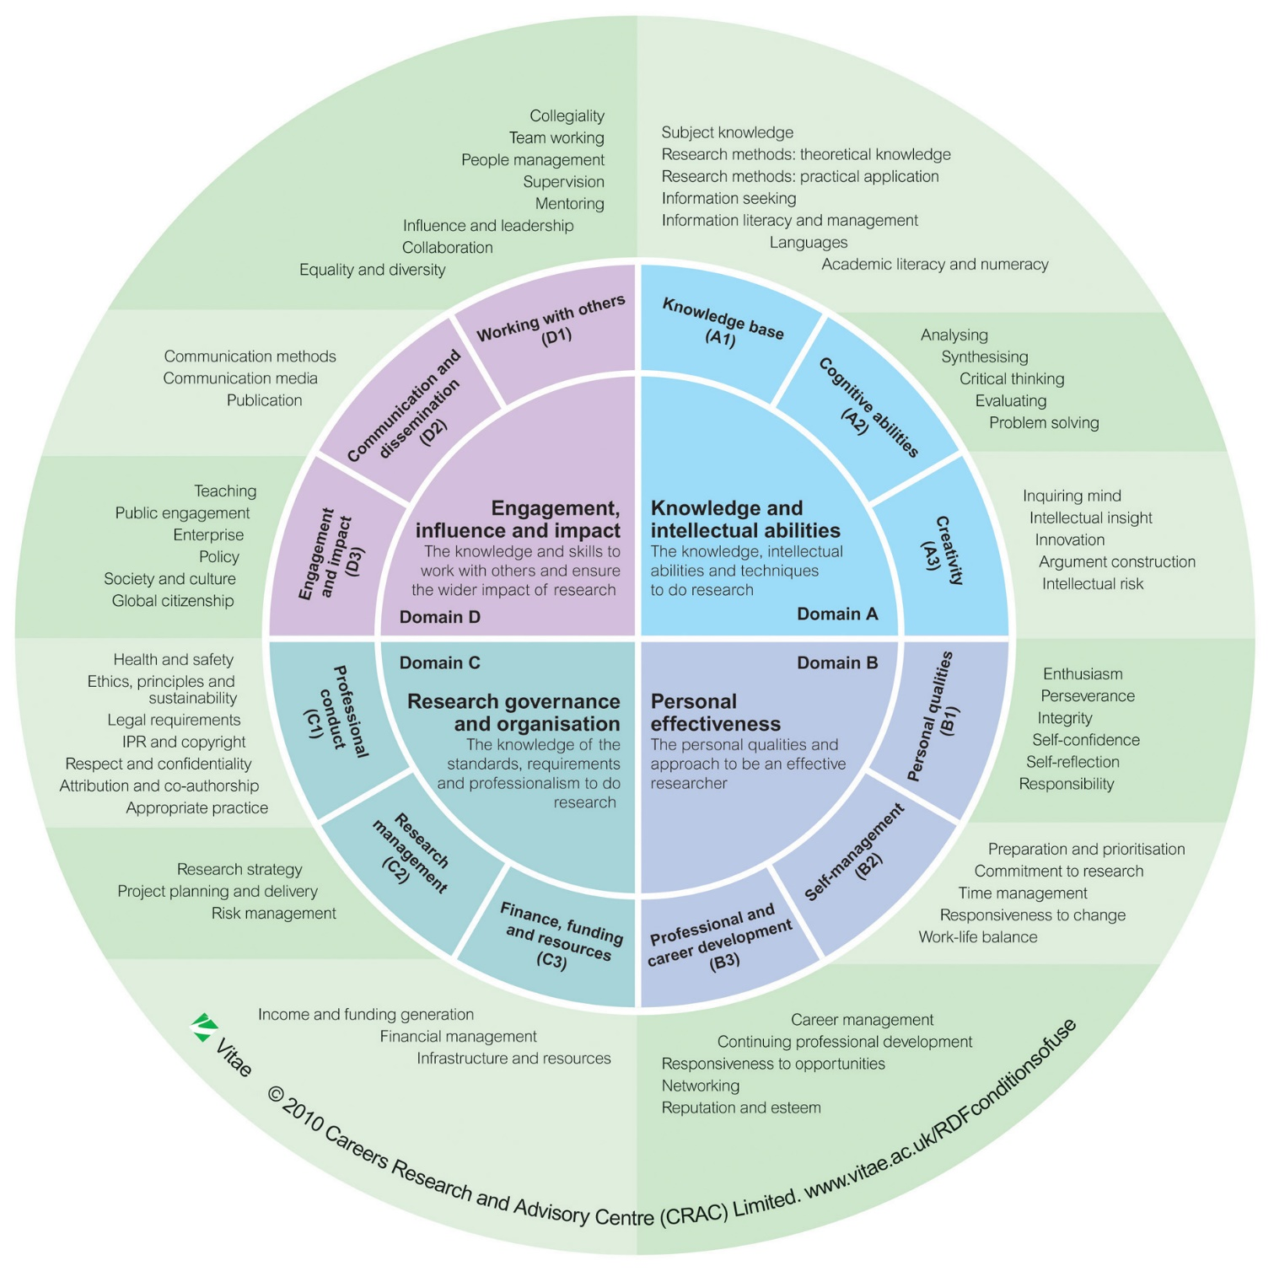
Annex 2. Example of a reflective statement (see Part C of the form)

Domain B Personal Effectiveness: reflection on development and plans for coming year

Over the last year I have worked really hard to take increasing responsibility (B1). I have been trying to be more pro-active and making more suggestions for research directions at my supervisory meetings, analysing my results in advance and working out why I have the results I do and the next steps I think I need to take in the research. This summer I also had the opportunity to help an MSc student with their work which involved taking responsibility for the work they were undertaking in the lab (steps towards phase 3). I trained the student in the techniques needed for their research and helped them analyse their data and decide the next steps for their research.

As my PhD has evolved I have increasingly realised that I have low self-confidence and now question the “level 2” that I scored in my RDF planner (B1). The event that made me realise this was my probationary meeting where I was really scared about not saying the right things and not being able to answer questions properly. I discussed this with a couple of colleagues who suggested that I enrol in Springboard which is a personal development programme for women, which I did. On reflection this was an excellent course which hopefully has helped me overcome some of my confidence issues. Work in progress!

Time management has always been struggle for me (B2) and following on from the winter school I have been focussing upon improving my time-management and planning I now have an excel spreadsheet on which I have all my tasks listed in terms of importance and immediacy. This helps ensure that I prioritise the things which are important for me and my research. I now also spend 30 minutes every Monday planning my week ahead. Springboard also covered time-management issues so I feel that I am making progress (moving towards phase 3).

Building upon the Schmoozing session at the winter school I spent a couple of days over the summer setting up my academic profiles (B3) on the web, Linkedin, etc. with a view to more effective networking. It felt like a positive thing to do but slightly disappointing as to date I have little to put up except my Masters and the outline of my PhD. I will need to build time into my schedule to keep these updated (consolidating phases 1 and 2). I will also explore joining appropriate user groups on Linkedin and starting a blog. SCISnack looks to be a good possibility for me in terms of blogging and building a reputation (B3).

Looking forward I would really like to work on my self-confidence and I was much more comfortable at my last supervisory meeting and even held my own with x who was critical of my experimental approach. I have signed up for a Science Museum Late at the Science museum (Dec 16) which I would never have even contemplated 6 months ago. I may even be moving towards Phase? 2! Improving time-management is another priority and there were lots of useful ideas at the EnvEast Winter School. However, I now feel that I am at the stage where I simply need to trial a number of systems and find out which work for me. So the in next few weeks (by end Nov 16) I plan to try a number of different systems “e.g. Pomodoro” and see how they work for me. 2 years into my PhD and am staring to consider my career options. Would possible be interested in an academic career so have enrolled on a course (SCI4RB3Y) on ‘Applying for postdoctoral positions’.

I have registered to attend the [X] conference in Stockholm and have been accepted to give both an oral and poster presentation. I’m really enthusiastic about this opportunity (B1) and it will definitely help my self-confidence (B1). I will need to ensure that I start my preparation in plenty of time (B2). The poster session at the Winter School has given me some ideas but I’ve heard from other PGRs that the Infographics training offered through ARIES is really great so I’ll register for that when it’s advertised. I will also register to take part in SCI3RA3Y ‘Presenting your Research’ to practice my oral presentation and get feedback before arranging a practice session with my supervisors.

CONTINUING SKILLS ASSESSMENT FEEDBACK FORM

Is the form comprehensively filled out and does it indicate sufficient engagement with training and development?

Is the student on track to complete the expected ARIES training? (Please see Handbook. Includes mandatory cohort training; initial and continuing TNAs; 5 days per year minimum advanced research training; 2 days per year additional CPD training; careers training; presentation at an international conference; experiential learning; adequate data and quantitative skills training)

Has the student submitted the required written work? (See Part D)

Is the student on track to achieve a skill level of phase 3 in at least six items from each of the four RDF domains of the Planner and phase 4 in at least two items from each of the four RDF domains?

Are there any other relevant training opportunities that might be useful to the student?

ARIES Training and Progression Panel approval
Name ................................................ Signature............................................ Date....................

